INTER-PROCESS COMMUNICATION
LAB # 10

Fall 2020
CSE302L System Programming Lab
Submitted by: Zain ul Abideen
Registration No. : 19pwcse1796
Class Section: A
"On my honor, as student of University of Engineering and Technology, I have neither given nor received unauthorized assistance on this academic work."
Student Signature:
Submitted to:
Engr. Madiha Sher
Sunday,March 6 , 2022
Department of Computer Systems Engineering University of Engineering and Technology, Peshawar
Task # 01:
A program in which a child writes a string to a pipe and the parent reads the string.
Code:
#include <stdio.h>
#include <unistd.h>
#include <sys/wait.h> #include <string.h> int main(int argc, char *argv[])
int fd[2]; int ret = pipe(fd); if(ret= -1)
perror("Failed to create a pipe"); return -1;
int x = fork(); if(x==-l)
perror("Failed to create a child process"); return -1; if(x==0)
char buffer[100]; printf("Child: Enter a message for parent.\n"); fgets(buffer,200,stdin); write(fd[l],buffer,strlen(buffer));
}else{ wait(NULL)•, char buffer[200]; read(fd[0],buffer,sizeof(buffer)); printf("Parent Recieved: ,buffer);
Output/Results:
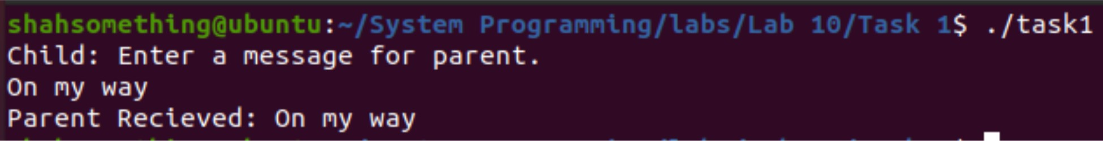
Task # 02:
Write a program that creates a process fan. Parent process writes to the pipe and all the child processes read the message from pipe and display it on stdout.
Code:
#include <stdio.h>
#include <unistd.h>
#include<sys/wait.h> #include<string.h>
int main(int argc, char *argv[])
int fd[2]; int ret = pipe(fd); char buffer[100]; if(ret==-l)
perror("Failed to create a pipe"); return -1;
for(int i=0;i<3;i++)
int x = fork(); if(x==-l)
perror("Failed to create a child process"); return -1;
if(x>0)
printf("\nEnter a message for Child %d:" ,i+l); fgets(buffer,sizeof(buffer),stdin); write(fd[l],buffer,strlen(buffer)); wait(NULL);
}else{ read(fd[0],buffer,sizeof(buffer)); printf("Child %d Received: %s" ,i+l,buffer); break;
Output:
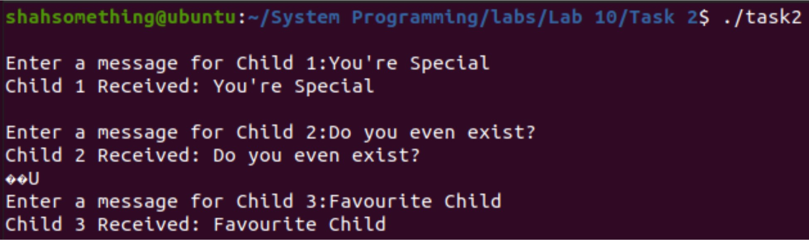
Task # 03:
Chatting between two process using FIFO
Write a Chatting application in which two processes can communicate using FIFO. Your program should satisfy the following specifications. The program should take the name of FIFO, will create the FIFO (if not created yet) and should open it for reading and writing. Program should take input from standard input and write it to FIFO and should read from FIFO and write to standard output in another process. Both reading and writing shall be done concurrently.
Code:
#include <stdio.h>
#include <unistd.h>
#include <fcntl.h>
#include <stdlib.h>
#include <sys/select.h>
#include <string.h>
#include <sys/stat.h> #include <errno.h>
int main(int argc, char *argv[])
if(argc!=2)
printf("Fifo name not provided\n"); return -1;
int fd,w,r,ret; if(mkfifo(argv[1],S_IRWXU)==-1)
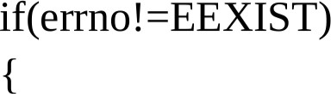
perror("Failed to create fifo\n"); return -1;
fd = open(argv[1],O_RDWR); if(fd==-l)
perror("Failed to open fifo\n"); return -1;
char str[512]; char str2[4] 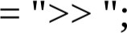fd set readset; sleep(4); while(l)
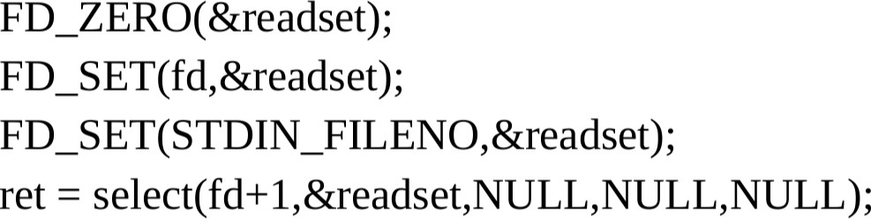
if(ret==-l)
perror("Error Using Select"); return -1;
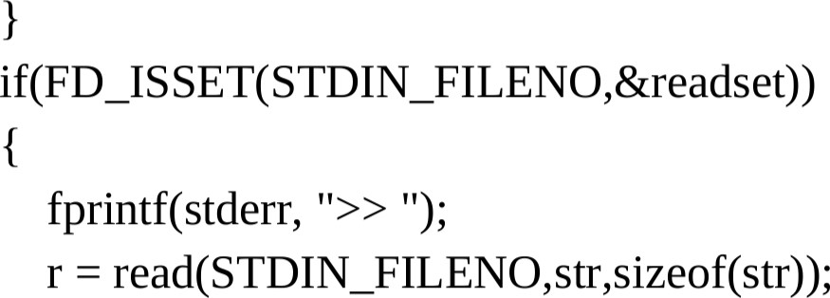
w = write(fd,str,r); if(w==-l)
perror("Error while writing to fifo"); return -1;
sleep(4); continue;
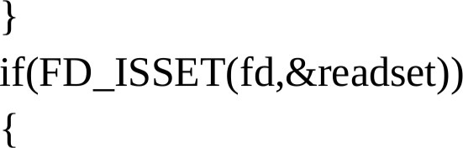
r = read(fd,str,sizeof(str)); if(r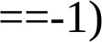
perror("Error while reading from fifo"); return -1;
} else if(r==0) continue; fprintf(stderr, "Recieved: ,str);
Output:
